### 

### Semester Two Examination, 2022

### Question/Answer booklet

# MATHEMATICS METHODS

**UNIT 3 & 4**

## Section One:

## Calculator-free

|  |  |
| --- | --- |
| **Your Name:** |  |
| **Your Teacher’s Name:** |  |

## Time allowed for this section

Reading time before commencing work: five minutes

Working time: fifty minutes

## Materials required/recommended for this section

***To be provided by the supervisor***

This Question/Answer booklet

Formula sheet

***To be provided by the candidate***

Standard items: pens (blue/black preferred), pencils (including coloured), sharpener, correction fluid/tape, eraser, ruler, highlighters

Special items: nil

## Important note to candidates

No other items may be taken into the examination room. It is **your** responsibility to ensure that you do not have any unauthorised material. If you have any unauthorised material with you, hand it to the supervisor **before** reading any further.

|  |  |  |  |  |  |
| --- | --- | --- | --- | --- | --- |
| Question | Marks | Max | Question | Marks | Max |
| 1 |  | 5 | 5 |  | 8 |
| 2 |  | 10 | 6 |  | 8 |
| 3 |  | 10 |  |  |  |
| 4 |  | 8 |  |  |  |

**Structure of this paper**

|  |  |  |  |  |  |
| --- | --- | --- | --- | --- | --- |
| Section | Number of questions available | Number of questions to be answered | Working time (minutes) | Marks available | Percentage of examination |
| Section One:  Calculator-free | 6 | 6 | 50 | 49 | 33 |
| Section Two:  Calculator-assumed | 11 | 11 | 93 | 100 | 67 |
|  |  |  |  | **Total** | 100 |

**Instructions to candidates**

1. The rules for the conduct of the Western Australian Certificate of Education ATAR course examinations are detailed in the *Year 12 Information Handbook 2019*. Sitting this examination implies that you agree to abide by these rules.
2. Write your answers in this Question/Answer booklet.
3. You must be careful to confine your answers to the specific questions asked and to follow any instructions that are specific to a particular question.
4. Additional pages for the use of planning your answer to a question or continuing your answer to a question have been provided at the end of this Question/Answer booklet. If you use the space to continue an answer, indicate in the original answer space where the answer is continued, i.e. give the page number.
5. **Show all your working clearly.**Your working should be in sufficient detail to allow your answers to be checked readily and for marks to be awarded for reasoning. Incorrect answers given without supporting reasoning cannot be allocated any marks. For any question or part question worth more than two marks, valid working or justification is required to receive full marks. If you repeat any question, ensure that you cancel the answer you do not wish to have marked.
6. It is recommended that you **do not use pencil**, except in diagrams.
7. The Formula sheet is **not** to be handed in with your Question/Answer booklet.

**Section One: Calculator-free (49 marks)**

This section has **six** questions. Answer **all** questions. Write your answers in the spaces provided.

Spare pages are included at the end of this booklet. They can be used for planning your responses and/or as additional space if required to continue an answer.

● Planning: If you use the spare pages for planning, indicate this clearly at the top of the page.

● Continuing an answer: If you need to use the space to continue an answer, indicate in the original answer space where the answer is continued, i.e. give the page number. Fill in the number of the question that you are continuing to answer at the top of the page.

Working time: 50 minutes.

**Question 1 (5 marks)**

The graph with equation $y=k{\left(2x-4\right)}^{3}$ is shown below.

Shaded region is between the curve and the  axis from  to .

<EFOFEX>

id:fxd{ace87c47-947b-4dcf-8fde-335509f8576c}


FXData:

</EFOFEX>

If the area of the shaded region is $17 {units}^{2}$, determine the value of $k$.

**Question 2 (10 marks)**

A random experiment can either result in a success with a probability of $p$ or a failure.

In an event, this random experiment is conducted twice. Each experiment is independent of the other. Let the number of successes be represented by $X$.

(a) State the distribution, and its parameters, that can be used to model the event described above. (2 marks)

The graph below shows of the variance for the distribution in part (a) for various values of .

<EFOFEX>

id:fxd{8dab9c5c-5cc4-493d-8aaa-4df2a9468115}


FXData:

</EFOFEX>

(b) Explain why the graph is continuous, despite the distribution being discrete. (1 mark)

(c) (i) State the value of $p$ for which the standard deviation of $X$ is maximised. (1 mark)

(ii) Hence determine the exact value of the standard deviation, for the value of $p$  
 in part (c)(i). (1 mark)

For the distribution in part (a), the probability that at least one of these experiments results in a success is $0.51$.

(d) (i) Show that ${\left(1-p\right)}^{2}=0.49$ (2 marks)

(ii) Hence show that the value of $p$ is $0.3$. (1 mark)

(e) Determine $E(X)$ for this distribution. (1 mark)

A second random variable $Y$ is defined as $Y\sim B(2, 0.7)$.

Given that $Var\left(X\right)=0.42$.

(f) Explain why $Var\left(Y\right)=Var(X)$. (1 mark)

**Question 3 (10 marks)**

(a) Determine whether the following represent or do not represent a probability distribution. Justify each answer.

(i) 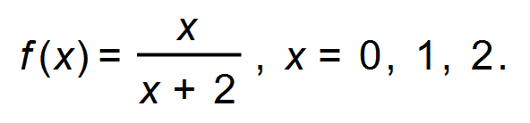 (1 mark)

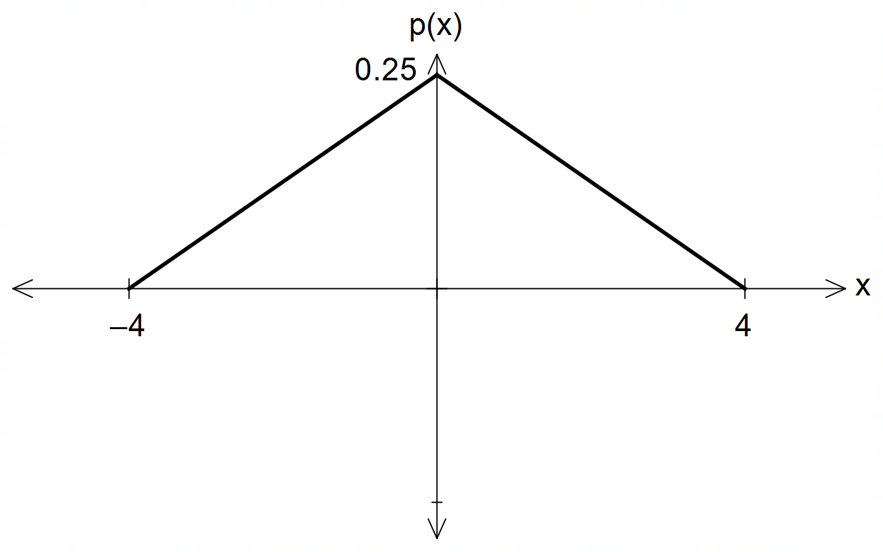(ii) (1 mark)

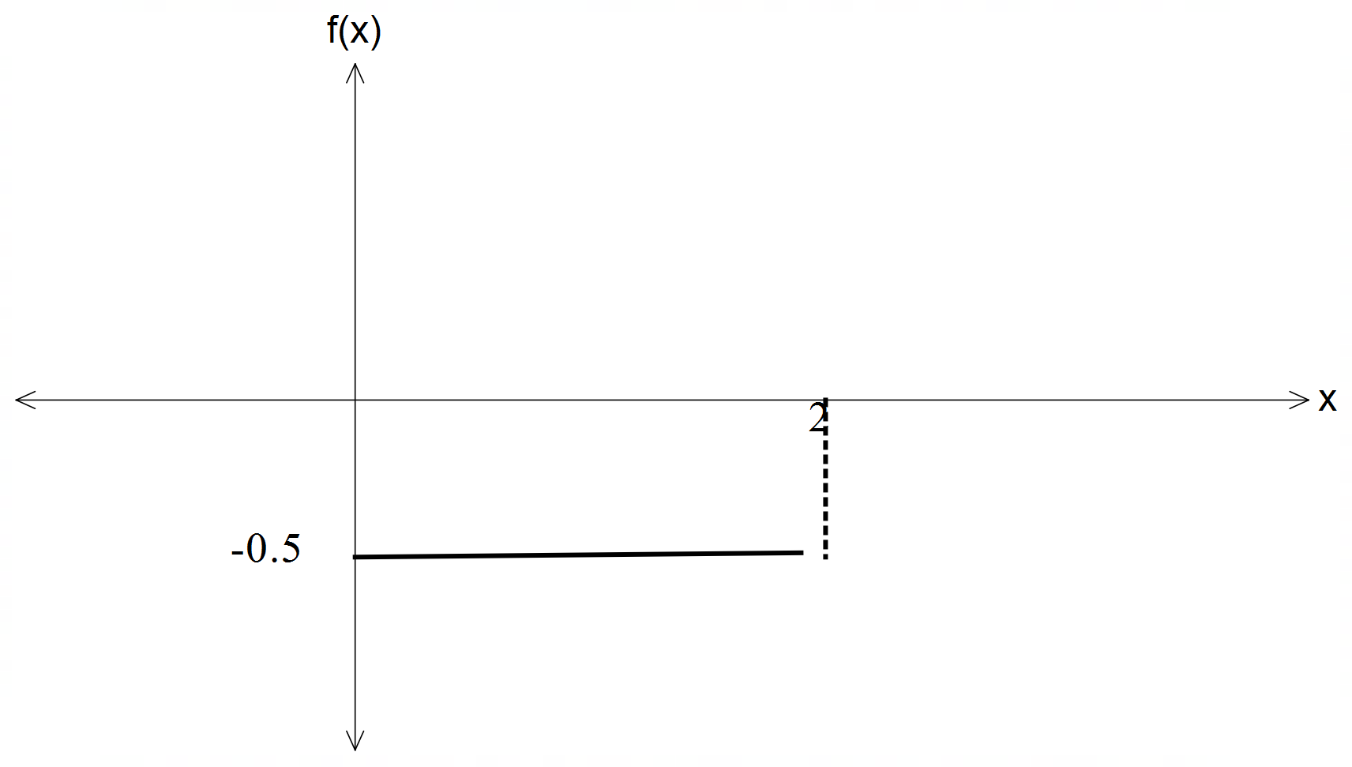

(iii) (1 mark)

(b) A probability distribution of a random variable *X* is given by

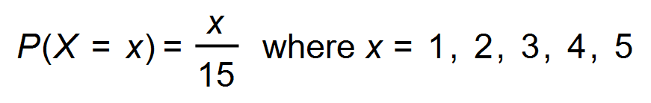 .

(i) Graph the probability function on the axes below. (2 marks)

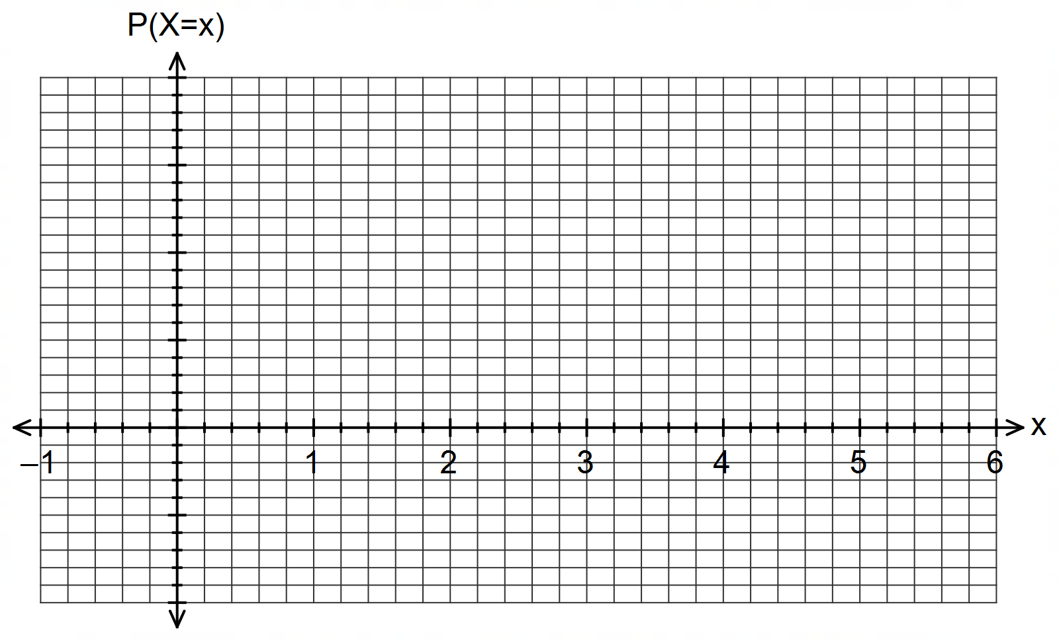

(ii) Determine the probability of obtaining a value of X less than 3. (1 mark)

(iii) Determine 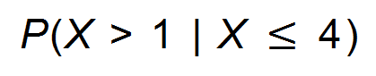. (2 marks)

(iv) State the cumulative probability distribution for *X*. (2 marks)

Question 4 (8 marks)

Determine the following:

(a) $\int{6e^{2x-3}}dx$. (1 mark)

(b) $\int_{0}^{\frac{π}{8}}{\underset{ }{\overset{ }{\sin{(4x)}}}}dx$. (2 marks)

(c) $f^{'}\left(\begin{matrix}π \\ \overline{6}\end{matrix}\right)$ when $f\left(x\right)=\begin{matrix}\cos{(3x)} \\ \overline{2+\sin\left(x\right)}\end{matrix}$. (3 marks)

(d) $\begin{matrix}d \\ \overline{dx}\end{matrix}\int_{1}^{x}{\underset{ }{\overset{ }{\cos\left(t+1\right)}}}dt$. (1 mark)

(e) $\int_{0}^{3}{\begin{matrix}d \\ \overline{dx}\end{matrix} \left(x e^{2x}\right)}dx$. (1 mark)

Question 5 (8 marks)

Components A and B form part of an electronic circuit, and properties of these components are measured $t$ seconds after the circuit is turned on.

(a) The rate of change of temperature, $T ℃$, of component A is given by $\begin{matrix}dT \\ \overline{dt}\end{matrix}=\begin{matrix}18t \\ \overline{{3t}^{2}+8}\end{matrix}$. Determine, in simplest form, the increase in temperature of this component during the first $4$ seconds. (4 marks)

(b) The current, $I$ amps, flowing through component B reaches a peak very quickly and then declines as time goes on, as modelled by $I\left(t\right)=\begin{matrix}2+\ln\left(t\right) \\ \overline{ \overset{ }{4t} }\end{matrix}$. Determine, in simplest form, the maximum current that flows through this component. (4 marks)

Question 6 (8 marks)

Let $f\left(x\right)=k\log_{6}{(x+6)}+c$, where $k$ and $c$ are constants.

The graph of $y=f(x)$ intersects line $L$ with equation $5y+2x+15=0$ when $x=0$ and

$x=-5$.

(a) Determine the value of the constant $c$ and the value of the constant $k$. (3 marks)

(b) Sketch the graph of $y=f(x)$ on the axes below. (3 marks)

<EFOFEX>
id:fxd{0c6ef0ae-80c4-413a-8fb3-f1663f6fb518}

FXData:

</EFOFEX>

(c) Given that $\log_{6}{(x+6)}=\begin{matrix}\ln{(x+6)} \\ \overline{ \ln{\overset{ }{\left(6\right)} }}\end{matrix}$, determine the value of $x$ where the slopes of

$y=f(x)$ and line $L$ are the same. (2 marks)

**End of questions**